**Experiment 7: Size Dependent Color Variation of Cu2O Nanoparticles by a Spectrophotometer**

**Name:** Vidhi Shah

**Reg. No.:** 21BCE1297

**Slot:** L11-L12

**Date:** 23/11/21

|  |  |  |  |  |  |
| --- | --- | --- | --- | --- | --- |
| **Sample No.** | **Vol. of Benedict’s reagent (mL)** | **Vol. of glucose solution (mL)** | **Vol. of NaOH 0.01 M (mL)** | **Turbidity (NTU)** | **Inference** |
| **A** | 0.5 | 4.5 | 45 | 57.7 | Faster-reaction (size↑Turbidty↑) |
| **B** | 1.0 | 9.0 | 40 | 52 |  |
| **C** | 1.5 | 13.5 | 35 | 43.2 |  |
| **D** | 2.0 | 18.0 | 30 | 35 | Slower-reaction (size↓Turbidty↓) |
| **E (Unknown Sample)** | 0.1*(50 – 42) = 0.8 | 0.9 (50 – 42) = 7.2 | X (from the graph) = 42 | 54 |  |

**Observations:**

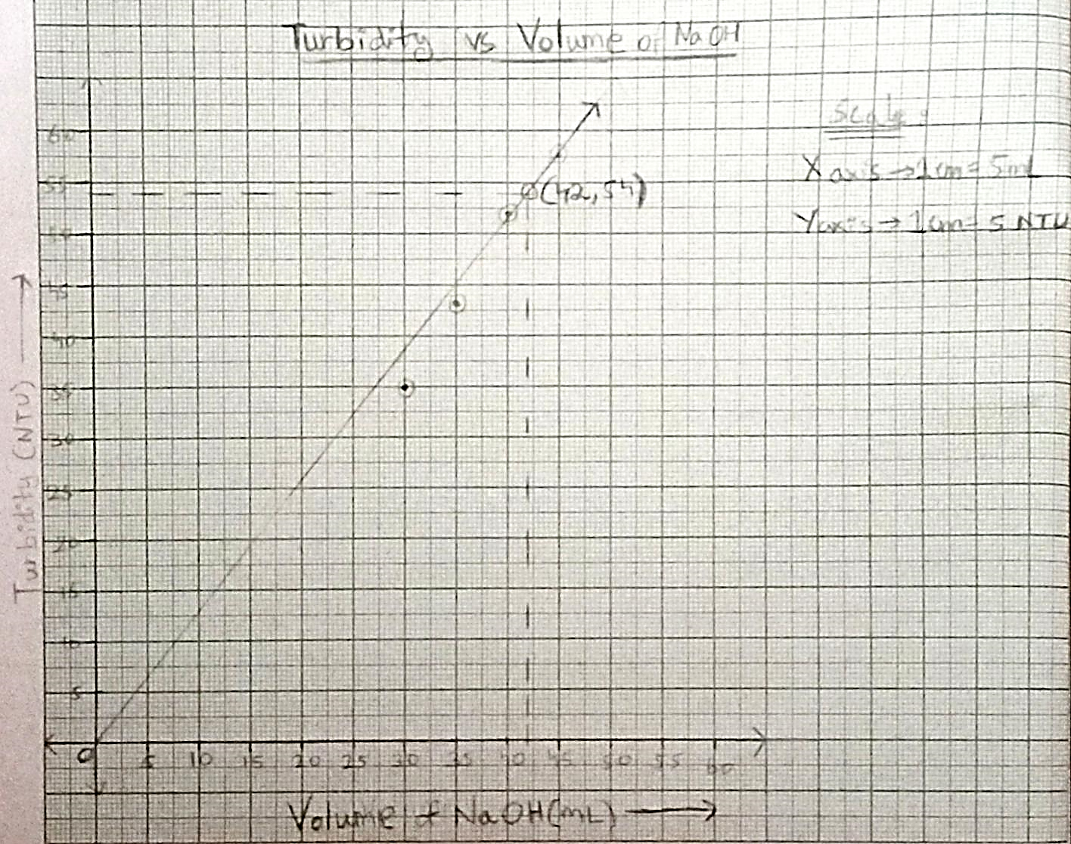**Graph:**

**Calculation:**

Volume of Benedict reagent **:** Volume of sugar solution = 1 **:** 9

Total volume of Cu2O solution = 50 mL

Unknown volume of NaOH = x mL = 42 mL

Benedict reagent + sugar solution = (50 – x) mL = 8 mL

Volume of benedict reagent = mL = 0.8 mL

Conc. of Benedict reagent (stock solution) = 240 mmol (w.r.t CuSO4)

Conc. of Cu(II) in unknown 50 mL solution = = **3.84 mmol**

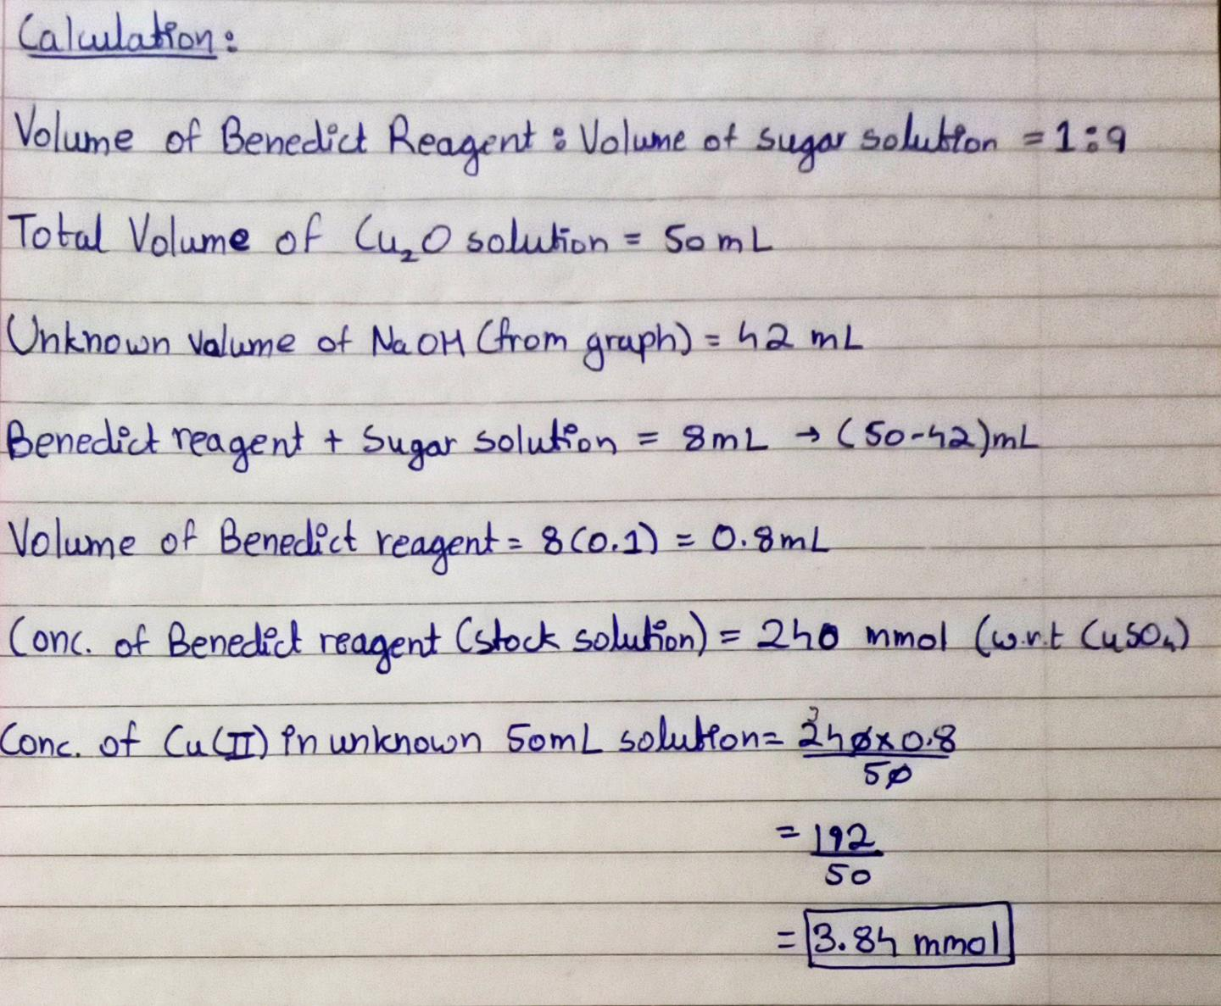

**Result:**

1. The volume of NaOH for the unknown solution **42 mL**.
2. The concentration Cu(II) solution is **3.84 mmol**.